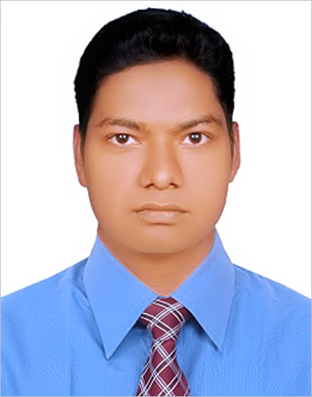
CURRICULUM VITAE

Md. Masud Rana
Contact Address & Number:
Address: 235/236, Block-cha, Road No-2, Mirpur-2, and Dhaka-1216

Mobile No: 01930-213905
E- Mail: masudrana4043@gmail.com

CAREER OBJECTIVE:

Looking for a dynamic and challenging work to utilize my background and willing to work in a creative and technical environment where there are scope to utilize knowledge and creativity. I am physically active and quickly adapted with very hard and tough environment.

PERSONAL SKILLS:

- Planning skills
- Managerial and leadership skills
- Ability to motivate a team
- Problem solving
- Able to co-ordinate several tasks simultaneously

Employment History:

Total year of experience: Over 2 years

I have been serving in “TVS Auto Bangladesh Ltd”. Since First April 2016 to till now. Present position in my existing organization Executive - Spare Parts Department W/H.

Job Responsibility:

- Managing all processes and functions within a busy ware house.
- Managing a team of up to 26 employees within the ware house.
- Coordinating racking and storing.
- Responsible for the ware house security and accountability.
- Ensuring stock levels are managed and controlled effectively.
- Using automated computer systems to monitor stock control.
- Implementing new projects.
- Making sure that all freight receipts and deliveries are carried out in time.
- Making sure smooth delivery at all branch, dealer and counter customers requirements.
- Stock & inventories management & supervision.

Previous Job Experience:
Attended 3 months internship program at PRIME BANK LIMITED (Shibpur Branch, Narsingdi) in the following deportments:
- General Advance
- Foreign Exchange Advance
- General Banking

Report Writing Experience:

- Strong skill in assignment and report writing.
- Unilever Bangladesh & Square Group
EDUCATIONAL ATTAINMENT:

Bachelor in Business Administration (BBA)
University Institute : Bangladesh University of Business & Technology
Major in : Marketing
Duration of course : 04 (Four) years
Result : 3.27 / First class (out of four)
Passing of year : 2015
Higher Secondary School Certificate (HSC)
Institute : Narsingdi Govt. College
Group : Business Studies
Result : 3.60 / First class (out of five)
Passing of year : 2010
Board : Dhaka
Secondary school certificate (SSC)
Institute : Kazi Mafiz Uddin High School
Group : Business Studies
Result : 4.13 / First class (out of five)
Passing of year : 2008
Board : Dhaka

Key Qualification:

- Good Knowledge on Computer.
- Good communication skill both in written and spoken.

Interest:

In new Technology of Computer.
- Also in Reading Books, Music, Traveling and Acting.

Language Proficiency:

- Proficiency in oral & written communication in Bengali & English.
- Strong interpersonal skills.

Computer Literacy:

Operating Software | Microsoft Windows 2000 and XP Professional
Application Software | Certificate in Computer Application, MS Office (MS-Word, MS-Excel, MS-PowerPoint)
Data Entry | 20 words /min. in English
Internet | Browsing, E-mail & Basic

Hobbies & Habits:
- Real Sporting & Gaming
- Computer Gaming
- Travel

PERSONAL INFORMATION
Father’s Name : late Md. Mojibor Rhaman
Mother’s Name : Ms. Karima
Date of Birth : December 11, 1992.
Place of Birth : Narsingdi
Sex : Male.
Blood group : B (+ve).
Height : 5′8′′
Religion : Islam
Marital status : Unmarried.
Nationality : Bangladeshi by Birth.
Permanent Address : Vill. Ghasirdia, P.O. Shaspur,
P.S. - Shibpur, Dist. - Narsingdi, Bangladesh.

REFERENCE

Md. Aslam Uddin  Chairman & Assistance Professor  Department of Marketing,  Bangladesh University of business & Technology (BUBT)  E-mail: aslam.du213@gmail.com  Phone: 01712624505 | Noor Mohammad Howlader  First Assistant Vice President &  Head of Branch, Shibpur, Narsingdi  E-mail: pblshibpur@primebank.com.bd  Mobile: 01755645474

I, hereby, declare that each of the information stated above is true and given in a cool brain.
Any willing mistake will result me in disqualification.

Date:
……………………..

